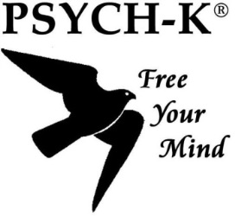 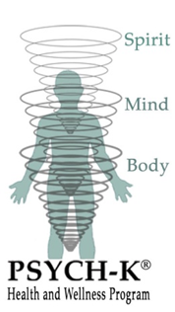

Change Reflection Sheet Name: Date:

*Believe that change is possible and look forward to a simple, effective and powerful session. This is a quick and simple change modality that does not require much talking. PSYCH-K accesses the sub-conscious mind and has the ability to re-write limiting beliefs that prevent the life that you want. To help with any curiosity go to the Resources page of the website.*

Reflect on the following two questions as preparation for a focused session.

How are things in your life right now?

(work, relationships, health, spirituality, prosperity, grief, confidence).

What patterns keep re-occurring that are limiting your life?

What do you want instead? (rather than what you don’t want)

(write in present tense and use positive language-think BIG!)